Invoice Monday, April 28, 2025

Project Description:

Finish maintenance topcoat on the vestibule entryway at 90 Park St. Brookline MA

Project Location:  90 Park St.  Brookline MA | 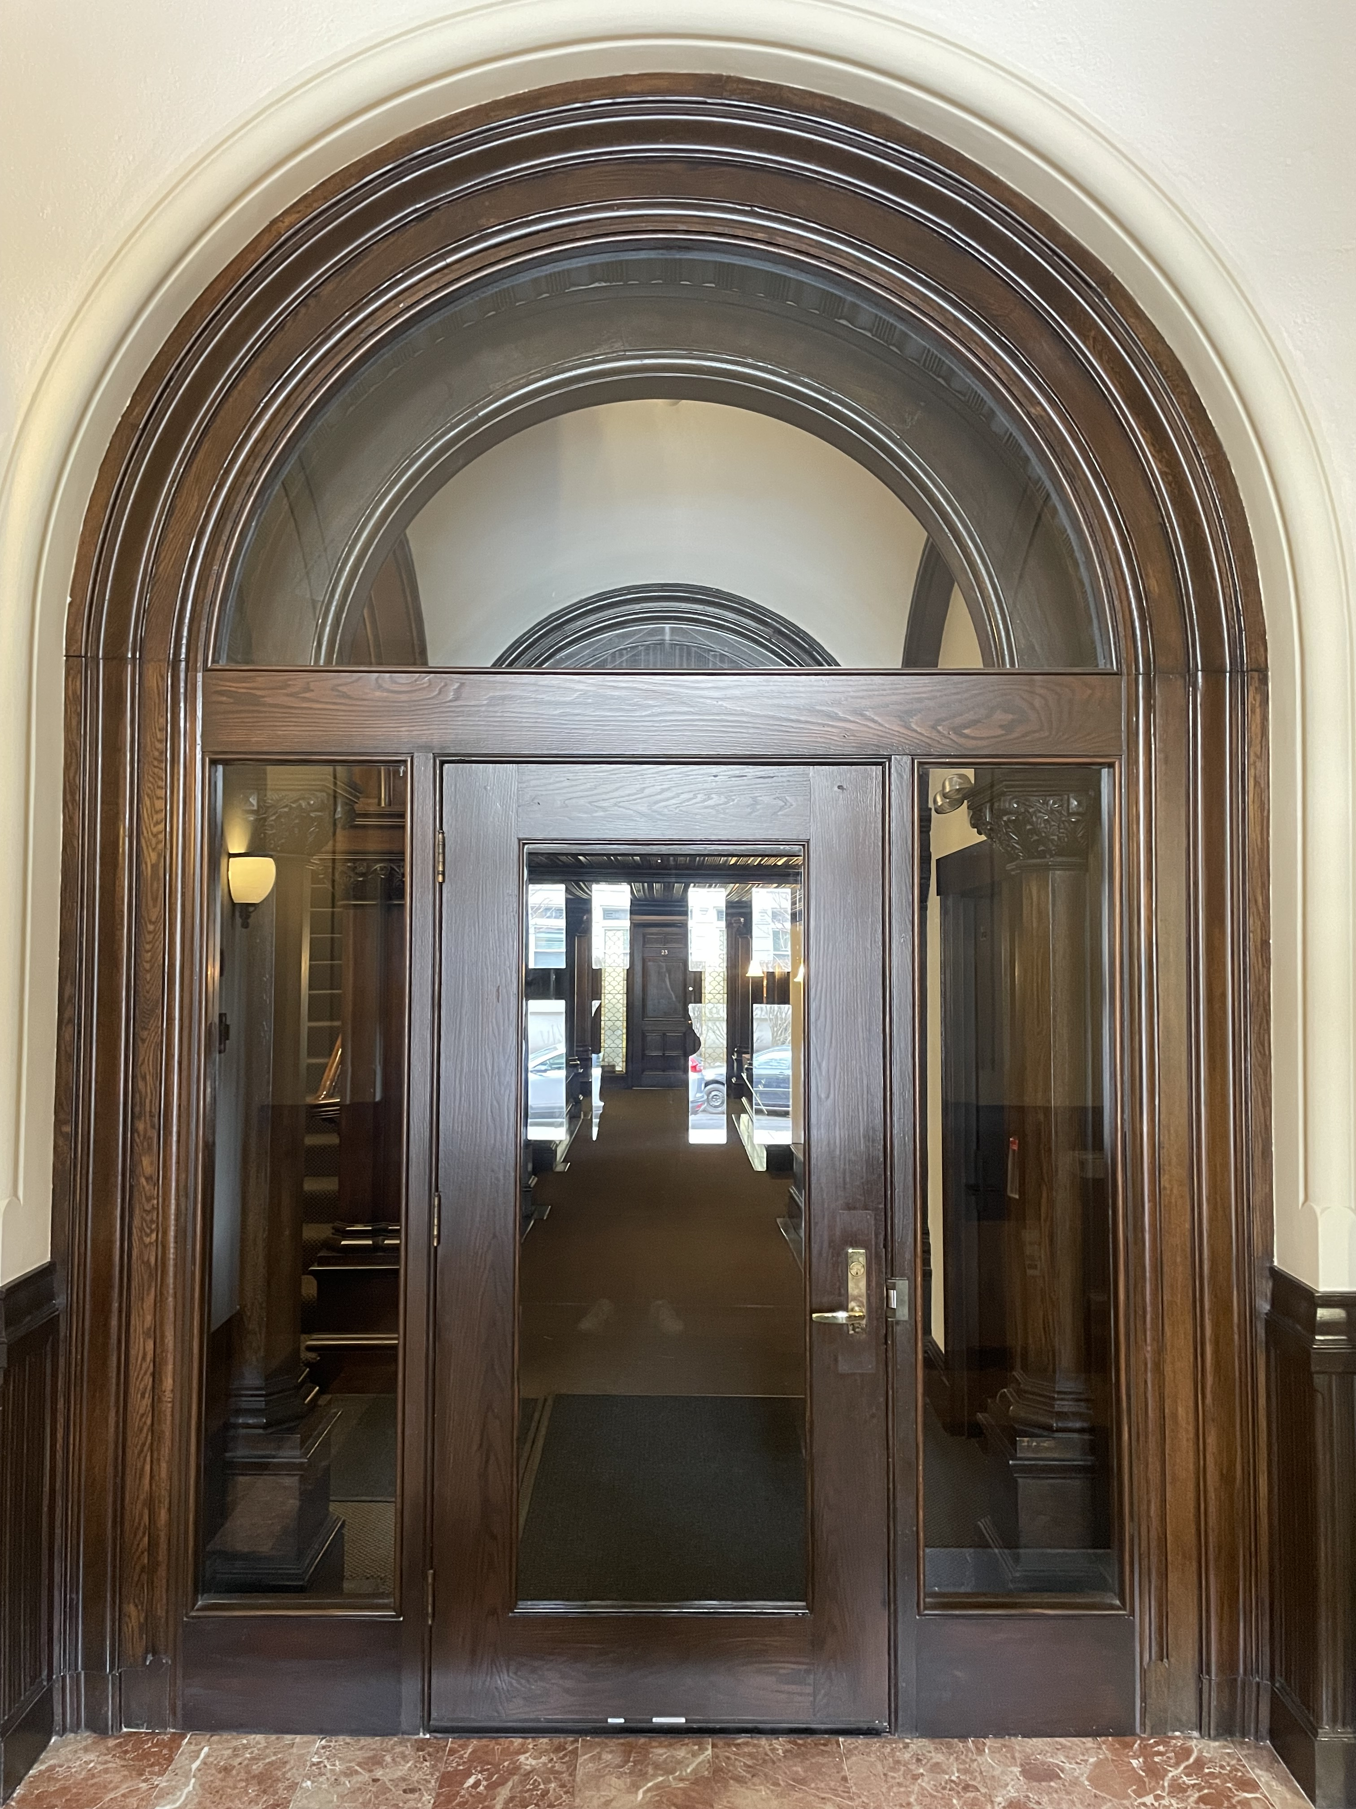
Customer Contact:
Nancy
90 Park St. Brookline MA
6177318121
90parkstreet@gmail.com

Amount paid (deposit)-$2205
Balance to be paid for the complete work-$2205

Thank you for your business. It was a pleasure working with you, and we looking towards working with you going forward.

-Sam

Vsevolod Sam Tsodokov
Principal/ Co-Founder
Boston Door Company
info@bostondoorcompany.net
(617) 233-2446

